Name: Maryam Mehreen

Sap Id: 35889

Lab: 4

Computer Networks

Task 1:

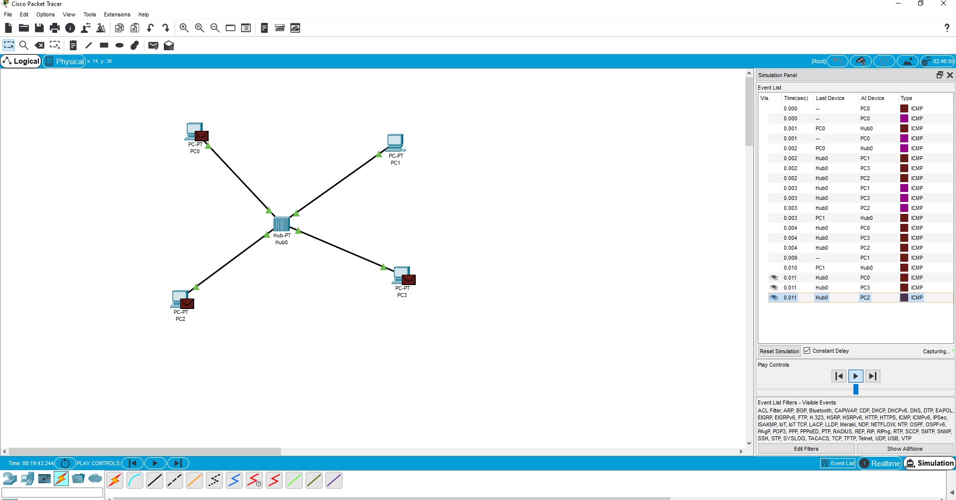

Task 2:

